**PRACTICAL 2 part 2**

**AIM:.**

**Creale a Web Page of your Institute which contains:**

**Description of Branch, Description of Courses, Department, Faculties using HTML and CSS Tags**

**SOLUTION:**

1. **Index.html:**

<!DOCTYPE *html*>

<html *lang*="en">

<head>

    <meta *charset*="UTF-8">

    <meta *http-equiv*="X-UA-Compatible" *content*="IE=edge">

    <meta *name*="viewport" *content*="width=device-width, initial-scale=1.0">

    <title>website</title>

    <link *rel*="stylesheet" *href*="css/style.css">

    <link *rel*="stylesheet" *href*="css/utils.css">

</head>

<body>

   <header>

<nav>

    <ul>

        <li> <a *href*="branches.html">Branches</a></li>

        <li><a *href*="courses.html">courses</a></li>

    </ul>

</nav>

   </header>

    <main>

          <div *class*="image">

           <div *class*="container"><h1>

             Welcome to Depstar

           </h1>

          </div>

          <div *class*="devang_p">

            <p >

             Devang Patel Institute of Advance Technology and Research (DEPSTAR) is a constituent of CHARUSAT. The institute is managed through a think tank of technocrats, administrators, scientists and engineers, educationalists, businessmen, stakeholders and other well-wishers from all parts of the world. DEPSTAR is patronized by IPCO Industries, headed by Philanthropist and Industrialist Shri Devang Patel. The institute envisions being a forerunner in teaching and research in advanced technologies. For this, in years to come, it will be an institute with advanced infrastructure, distinguished faculty, networking with global institutes and implementing most modern processes.

            </p>

          </div>

          </div>

<div *class*="footer">

  <div *class*="flex-all-center">

    <p *class*="p">Copyright &copy; charusat.com</p>

    <div *class*="location">

    <svg *xmlns*="http://www.w3.org/2000/svg" *width*="16" *height*="16" *fill*="currentColor" *class*="bi bi-geo-alt-fill" *viewBox*="0 0 16 16">

        <path *d*="M8 16s6-5.686 6-10A6 6 0 0 0 2 6c0 4.314 6 10 6 10zm0-7a3 3 0 1 1 0-6 3 3 0 0 1 0 6z"/>

      </svg></div>

    <p *class*="p">139, CHARUSAT Campus, Highway, Off, Nadiad - Petlad Rd, Changa, Gujarat 388421</p>

    <div *class*="reviews">

       reviews <input *type*="text">

    </div>

           <ul *class*="icons">

               <li *class*="icons">

<a *href*="https://www.instagram.com/thecharusat/?hl=en">

                   <svg *xmlns*="http://www.w3.org/2000/svg" *width*="16" *height*="16" *fill*="currentColor" *class*="bi bi-instagram" *viewBox*="0 0 16 16">

                    <path *d*="M8 0C5.829 0 5.556.01 4.703.048 3.85.088 3.269.222 2.76.42a3.917 3.917 0 0 0-1.417.923A3.927 3.927 0 0 0 .42 2.76C.222 3.268.087 3.85.048 4.7.01 5.555 0 5.827 0 8.001c0 2.172.01 2.444.048 3.297.04.852.174 1.433.372 1.942.205.526.478.972.923 1.417.444.445.89.719 1.416.923.51.198 1.09.333 1.942.372C5.555 15.99 5.827 16 8 16s2.444-.01 3.298-.048c.851-.04 1.434-.174 1.943-.372a3.916 3.916 0 0 0 1.416-.923c.445-.445.718-.891.923-1.417.197-.509.332-1.09.372-1.942C15.99 10.445 16 10.173 16 8s-.01-2.445-.048-3.299c-.04-.851-.175-1.433-.372-1.941a3.926 3.926 0 0 0-.923-1.417A3.911 3.911 0 0 0 13.24.42c-.51-.198-1.092-.333-1.943-.372C10.443.01 10.172 0 7.998 0h.003zm-.717 1.442h.718c2.136 0 2.389.007 3.232.046.78.035 1.204.166 1.486.275.373.145.64.319.92.599.28.28.453.546.598.92.11.281.24.705.275 1.485.039.843.047 1.096.047 3.231s-.008 2.389-.047 3.232c-.035.78-.166 1.203-.275 1.485a2.47 2.47 0 0 1-.599.919c-.28.28-.546.453-.92.598-.28.11-.704.24-1.485.276-.843.038-1.096.047-3.232.047s-2.39-.009-3.233-.047c-.78-.036-1.203-.166-1.485-.276a2.478 2.478 0 0 1-.92-.598 2.48 2.48 0 0 1-.6-.92c-.109-.281-.24-.705-.275-1.485-.038-.843-.046-1.096-.046-3.233 0-2.136.008-2.388.046-3.231.036-.78.166-1.204.276-1.486.145-.373.319-.64.599-.92.28-.28.546-.453.92-.598.282-.11.705-.24 1.485-.276.738-.034 1.024-.044 2.515-.045v.002zm4.988 1.328a.96.96 0 1 0 0 1.92.96.96 0 0 0 0-1.92zm-4.27 1.122a4.109 4.109 0 1 0 0 8.217 4.109 4.109 0 0 0 0-8.217zm0 1.441a2.667 2.667 0 1 1 0 5.334 2.667 2.667 0 0 1 0-5.334z"/>

                  </svg>

                </a>

               </li>

               <li *class*="icons">

                   <a *href*="https://www.facebook.com/thecharusat/">

                   <svg *xmlns*="http://www.w3.org/2000/svg" *width*="16" *height*="16" *fill*="currentColor" *class*="bi bi-facebook" *viewBox*="0 0 16 16">

                     <path *d*="M16 8.049c0-4.446-3.582-8.05-8-8.05C3.58 0-.002 3.603-.002 8.05c0 4.017 2.926 7.347 6.75 7.951v-5.625h-2.03V8.05H6.75V6.275c0-2.017 1.195-3.131 3.022-3.131.876 0 1.791.157 1.791.157v1.98h-1.009c-.993 0-1.303.621-1.303 1.258v1.51h2.218l-.354 2.326H9.25V16c3.824-.604 6.75-3.934 6.75-7.951z"/>

                   </svg>

                </a>

               </li>

               <li *class*="icons">

                <a *href*="https://www.charusat.ac.in/">

                   <svg *xmlns*="http://www.w3.org/2000/svg" *width*="16" *height*="16" *fill*="currentColor" *class*="bi bi-google" *viewBox*="0 0 16 16">

                     <path *d*="M15.545 6.558a9.42 9.42 0 0 1 .139 1.626c0 2.434-.87 4.492-2.384 5.885h.002C11.978 15.292 10.158 16 8 16A8 8 0 1 1 8 0a7.689 7.689 0 0 1 5.352 2.082l-2.284 2.284A4.347 4.347 0 0 0 8 3.166c-2.087 0-3.86 1.408-4.492 3.304a4.792 4.792 0 0 0 0 3.063h.003c.635 1.893 2.405 3.301 4.492 3.301 1.078 0 2.004-.276 2.722-.764h-.003a3.702 3.702 0 0 0 1.599-2.431H8v-3.08h7.545z"/>

                   </svg>

              </a>

               </li>

    </ul>

  </div>

</div>

    </main>

</body>

</html>

**Note:**

Here added css is in the externel file

**Style.css:**

*@import* url('https://fonts.googleapis.com/css2?family=Glory:wght@300&display=swap');

*{

    margin: 0;

    padding: 0;

    box-sizing: border-box;

}

nav ul{

    display: flex;

    justify-content: flex start;

    align-items: center;

    height: 50px;

}

nav ul li{

    list-style: none;

    padding: 0 23px;

}

nav ul li a{

    color: rgb(10, 11, 14);

    text-decoration: none;

}

nav ul li a*:hover*{

color: rgb(69, 88, 75);

}

header{

    background-color: rgb(202, 216, 241);

    font-family: 'Glory', sans-serif;

}

*.footer*{

    background-color: rgba(150, 150, 150, 0.288);

    font-family: 'Glory', sans-serif;

}

*.reviews*{

margin: 5vw;

}

*.icons*{

    text-decoration: none;

     list-style: none;

     display: flex;

    justify-content: flex start;

    align-items: center;

    padding: 1vw;

}

a{

    color: black;

}

*.p*{

    padding: 5vw;

}

*.location*{

    padding: 3vw;

}

*.image* {

    background: rgba(2, 2, 2, 0.596) url("/img/20211214_081658.jpg");

    background-blend-mode: darken;

    height: 110vh;

    background-repeat: no-repeat;

    background-size:cover;

    position: relative;

  }

*.column* {

    float: left;

    width: 25%;

    padding: 200px 10px;

  }

*.row* {margin: 0 50px;}

*.row:after* {

    content: "";

    display: table;

    clear: both;

  }

*@media* screen and (max-width: 600px) {

*.column* {

      width: 100%;

      display: block;

      margin-bottom: 20px;

    }

  }

*.card* {

    box-shadow: 0 14px 14px 0 rgba(12, 12, 12, 0.575);

    padding: 88px;

    text-align: center;

    background-color: #64626285;

    border-radius: 20px;

  }

*.container*{

    display: flex;

    justify-content: center;

    align-items: center;

    padding-top: 25vh;

}

*.container* h1{

    font-size: 80px;

color: rgba(231, 193, 144, 0.562);

}

*.devang_p*{

display: flex;

text-align: center;

justify-content: center;

    align-content: center;

    width: 70%;

   color: rgba(248, 248, 248, 0.425);

    margin: auto;

    padding-top: 10vh;

    word-spacing: 2px;

}

**Utils.css:**

*.flex-all-center*{

    display: flex;

    justify-content: center;

    align-items: center;

}

1. **branches.html:**

<!DOCTYPE *html*>

<html *lang*="en">

<head>

    <meta *charset*="UTF-8">

    <meta *http-equiv*="X-UA-Compatible" *content*="IE=edge">

    <meta *name*="viewport" *content*="width=device-width, initial-scale=1.0">

    <title>website</title>

    <link *rel*="stylesheet" *href*="css/style_branches.css">

    <link *rel*="stylesheet" *href*="css/utils.css">

</head>

<body>

   <header>

<nav>

    <ul>

        <li> <a *href*="branches.html">Branches</a></li>

        <li><a *href*="courses.html">courses</a></li>

    </ul>

</nav>

   </header>

    <main>

          <div *class*="image">

            <div *class*="row">

              <div *class*="column">

                <div *class*="card">

                  <h3>Bachelor of Technology <br>

                  (Computer Engineering)</h3> <br>

                  <h4>Course Duration:</h4> 04 Years

                  <h4>Intake:</h4> &nbsp; 120 Seats

                  <h4>Fees:</h4> &nbsp; 98,000

                </div>

              </div>

              <div *class*="column">

                <div *class*="card">

                  <h3>Bachelor of Technology

                    (Computer Science andEngineering)</h3> <br>

                    <h4>Course Duration:</h4> 04 Years

                    <h4>Intake:</h4> &nbsp; 120 Seats

                    <h4>Fees:</h4> &nbsp; 98,000

                </div>

              </div>

              <div *class*="column">

                <div *class*="card">

                  <h3>Bachelor of Technology <br>

                    (Information and Technology)</h3> <br>

                    <h4>Course Duration:</h4> 04 Years

                    <h4>Intake:</h4> &nbsp; 60 Seats

                    <h4>Fees:</h4> &nbsp; 98,000

                </div>

              </div>

            </div>

          </div>

    </main>

</body>

</html>

**Style_branches.css:**

*@import* url('https://fonts.googleapis.com/css2?family=Glory:wght@300&display=swap');

*{

    margin: 0;

    padding: 0;

    box-sizing: border-box;

}

nav ul{

    display: flex;

    justify-content: flex start;

    align-items: center;

    height: 50px;

}

nav ul li{

    list-style: none;

    padding: 0 23px;

}

nav ul li a{

    color: rgb(10, 11, 14);

    text-decoration: none;

}

nav ul li a*:hover*{

color: rgb(69, 88, 75);

}

header{

    background-color: rgb(202, 216, 241);

    font-family: 'Glory', sans-serif;

}

*.footer*{

    height:1vh ;

    font-family: 'Glory', sans-serif;

}

*.reviews*{

margin: 5vw;

}

*.icons*{

    text-decoration: none;

     list-style: none;

     display: flex;

    justify-content: flex start;

    align-items: center;

    padding: 1vw;

}

a{

    color: black;

}

*.p*{

    padding: 5vw;

}

*.location*{

    padding: 3vw;

}

*.image* {

    background: rgba(2, 2, 2, 0.342) url("/img/img1.jpg");

    background-blend-mode: darken;

*/* background-color: #cccccc; */*

    height: 100vh;

*/* background-position: center; */*

    background-repeat: no-repeat;

    background-size:cover;

*/* position: relative; */*

  }

*.column* {

    float: left;

    width: 33%;

    padding: 160px 10px;

  }

*.row* {margin: 0 70px;}

*.row:after* {

    content: "";

    display: table;

    clear: both;

  }

*@media* screen and (max-width: 600px) {

*.column* {

      width: 100%;

      display: block;

      margin-bottom: 20px;

    }

  }

*.card* {

    box-shadow: 0 14px 14px 0 rgba(12, 12, 12, 0.575);

    padding-top: 50px;

    padding-bottom: 30px;

    text-align: center;

    background-color: #b1b0b060;

    border-radius: 20px;

    color: rgba(0, 0, 0, 0.767);

  }

1. **courses.html:**

<!DOCTYPE *html*>

<html *lang*="en">

<head>

    <meta *charset*="UTF-8">

    <meta *http-equiv*="X-UA-Compatible" *content*="IE=edge">

    <meta *name*="viewport" *content*="width=device-width, initial-scale=1.0">

    <title>website</title>

    <link *rel*="stylesheet" *href*="css/style_courses.css">

    <link *rel*="stylesheet" *href*="css/utils.css">

</head>

<body>

   <header>

<nav>

    <ul>

        <li> <a *href*="branches.html">Branches</a></li>

        <li><a *href*="courses.html">courses</a></li>

    </ul>

</nav>

   </header>

    <main>

          <div *class*="image">

            <div *class*="row">

              <div *class*="column">

                <div *class*="card">

                  <h3>Here is Some of the brief idea about courses being taught here in IT</h3>

                </div>

              </div>

            </div>

            <a  *class*="screenshot" *href*="screenshots.html">click here to view courses details</a>

          </div>

    </main>

</body>

</html>

**Screenshots.html**

<!DOCTYPE *html*>

<html *lang*="en">

<head>

    <meta *charset*="UTF-8">

    <meta *http-equiv*="X-UA-Compatible" *content*="IE=edge">

    <meta *name*="viewport" *content*="width=device-width, initial-scale=1.0">

    <title>Document</title>

</head>

<body>

    <center>

    <h2>First Year</h2>

    <img *src*="img/1.png" *alt*="">

    <hr>

    <h2>Second Year</h2>

    <img *src*="img/2.png" *alt*="">

    <hr>

    <h2>Third Year</h2>

    <img *src*="img/3.png" *alt*="">

    <hr>

    <h2>Fourth Year</h2>

    <img *src*="img/4.png" *alt*="">

</center>

</body>

</html>

**Style_courses.css:**

*@import* url('https://fonts.googleapis.com/css2?family=Glory:wght@300&display=swap');

*{

    margin: 0;

    padding: 0;

    box-sizing: border-box;

}

nav ul{

    display: flex;

    justify-content: flex start;

    align-items: center;

    height: 50px;

}

nav ul li{

    list-style: none;

    padding: 0 23px;

}

nav ul li a{

    color: rgb(10, 11, 14);

    text-decoration: none;

}

nav ul li a*:hover*{

color: rgb(69, 88, 75);

}

header{

    background-color: rgb(202, 216, 241);

    font-family: 'Glory', sans-serif;

}

*.footer*{

    height:1vh ;

    font-family: 'Glory', sans-serif;

}

*.reviews*{

margin: 5vw;

}

*.icons*{

    text-decoration: none;

     list-style: none;

     display: flex;

    justify-content: flex start;

    align-items: center;

    padding: 1vw;

}

a{

    color: black;

}

*.p*{

    padding: 5vw;

}

*.location*{

    padding: 3vw;

}

*.image* {

    background: rgba(2, 2, 2, 0.342) url("/img/img1.jpg");

    background-blend-mode: darken;

*/* background-color: #cccccc; */*

    height: 100vh;

*/* background-position: center; */*

    background-repeat: no-repeat;

    background-size:cover;

*/* position: relative; */*

  }

*.column* {

    float: left;

    width: 80%;

    padding: 20px 10px;

  }

*.row* {margin: 0 350px;}

*.row:after* {

    content: "";

    display: table;

    clear: both;

  }

*@media* screen and (max-width: 600px) {

*.column* {

      width: 100%;

      display: block;

      margin-bottom: 20px;

    }

  }

*.card* {

    box-shadow: 0 14px 14px 0 rgba(12, 12, 12, 0.575);

    padding-top: 100px;

    padding-bottom: 100px;

    text-align: center;

    padding-left: 10px ;

    background-color: #e9e9e960;

    border-radius: 20px;

    color: rgb(0, 0, 0);

  }

*.column1* {

    float: center;

    width: 33.33%;

    padding: 5px;

  }

*.row1::after* {

    content: "";

    clear: both;

    display: table;

  }

*@media* screen and (max-width: 500px) {

*.column1* {

      width: 100%;

    }

  }

*.screenshot*{

    display:block ;

text-align: center;

font-size: larger;

color: antiquewhite;

  }

**Output:**

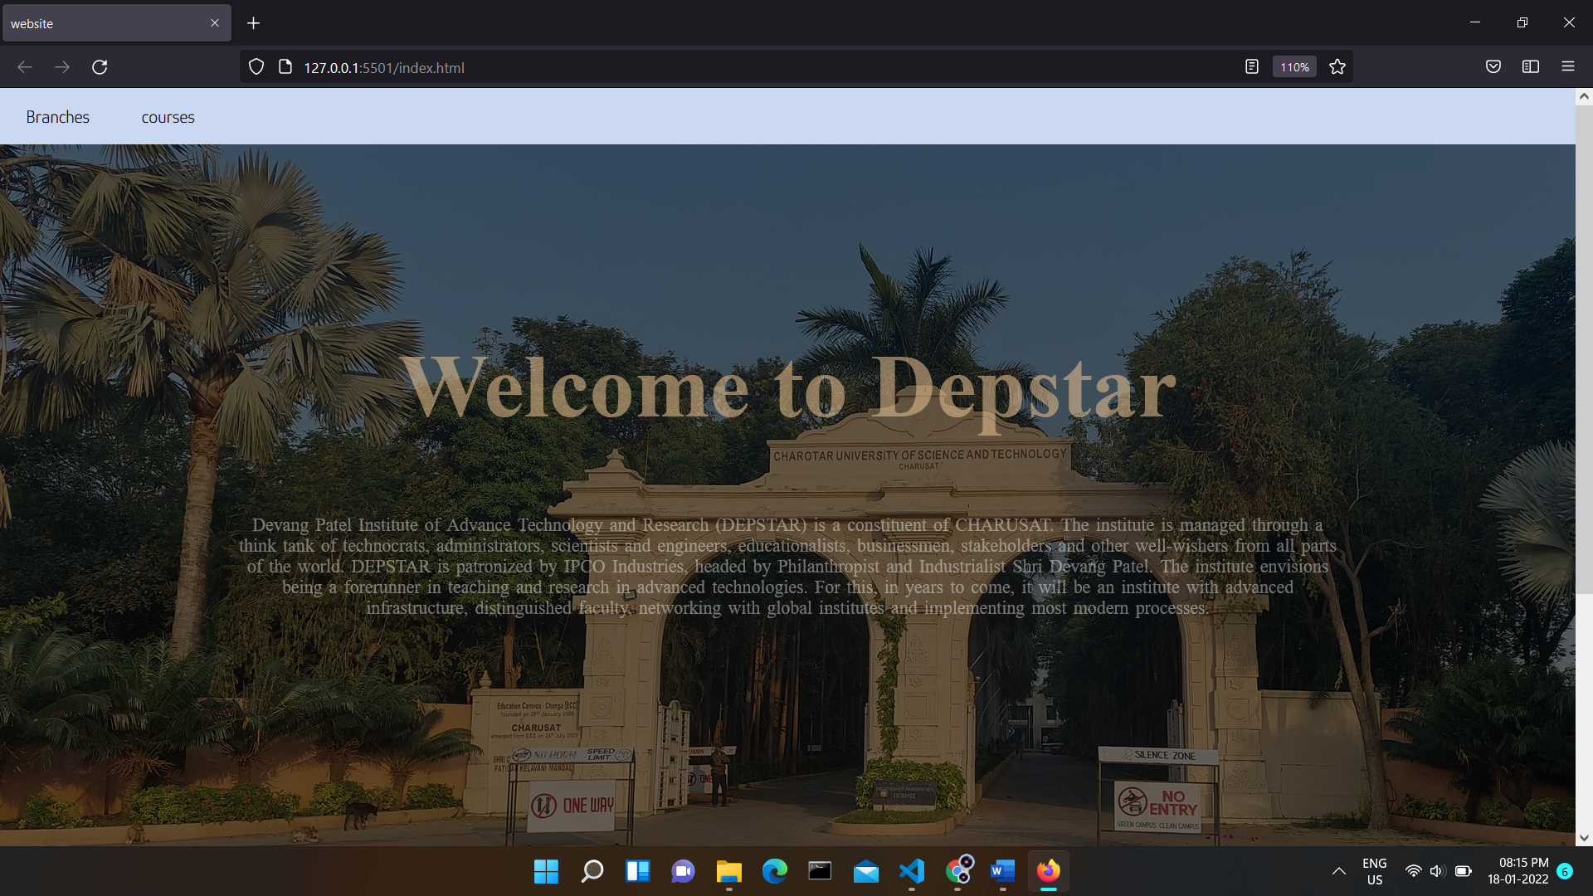

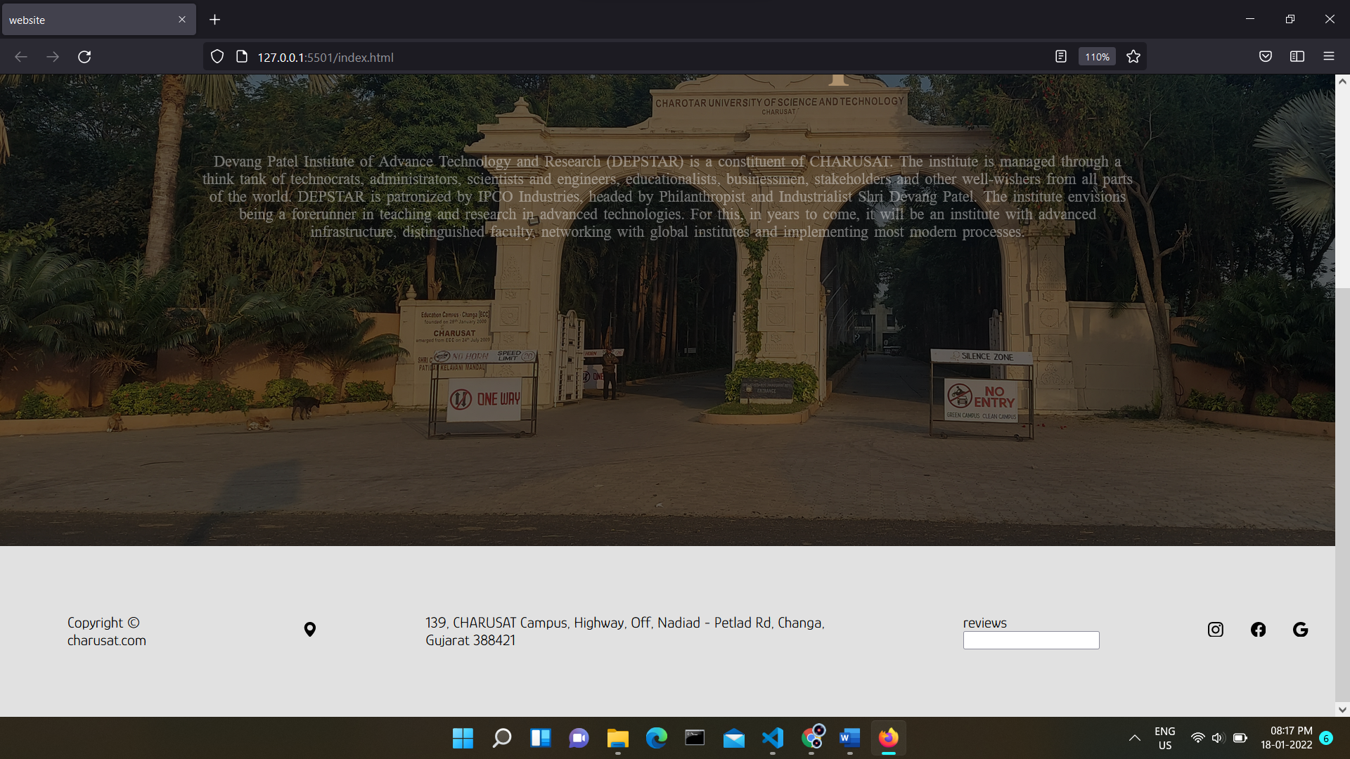

Hover effect:

Normal



Hovered

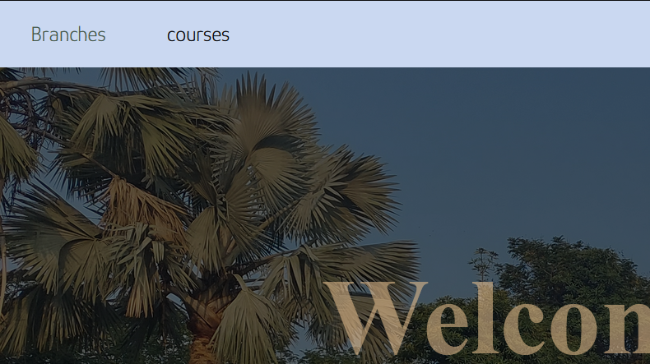

Branches section:

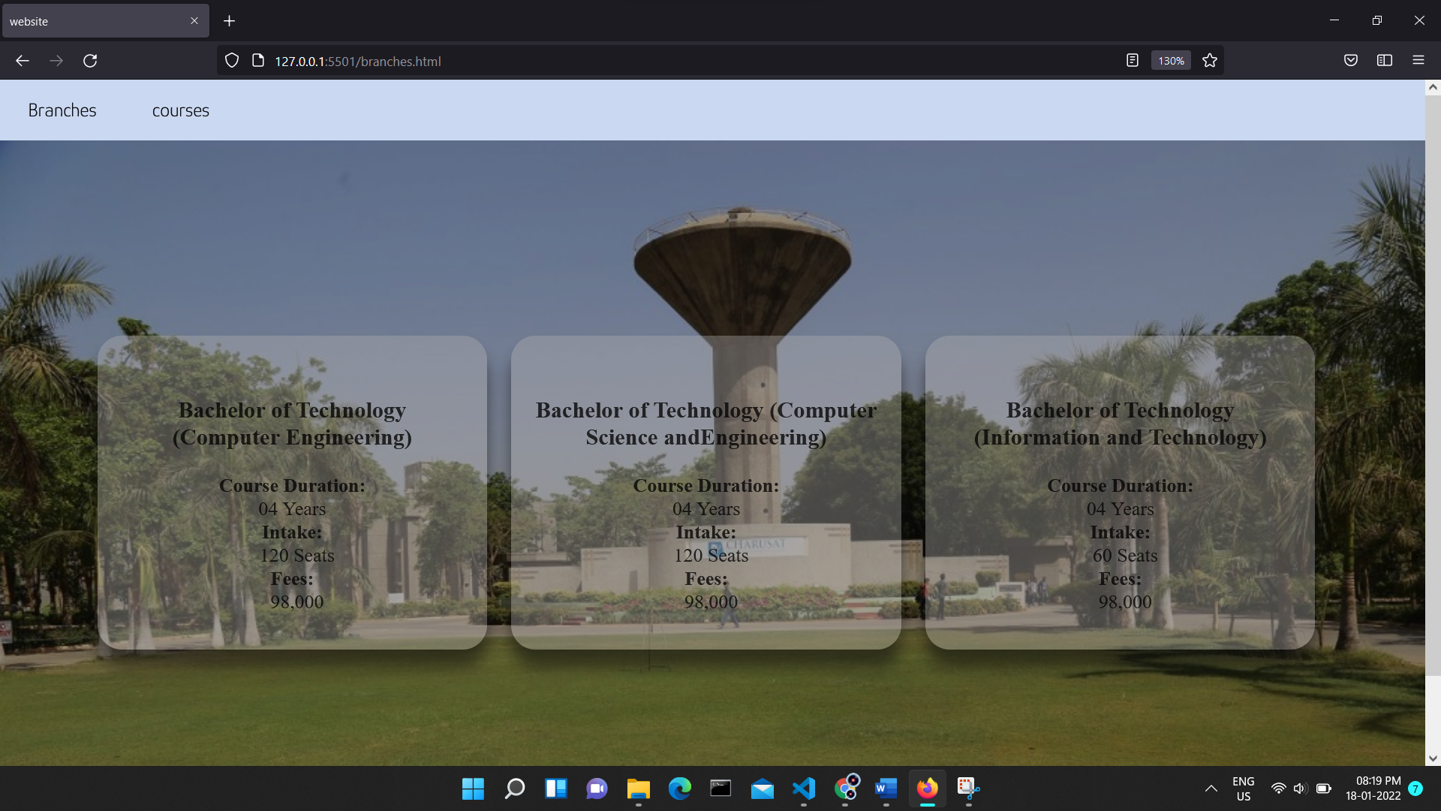

Courses section:

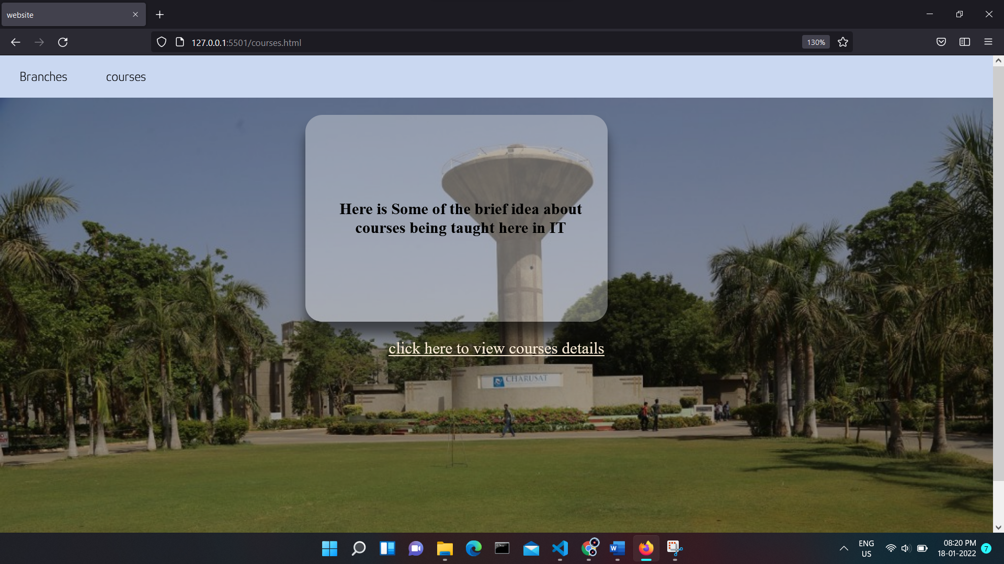

After clicking to the link in the above page says ”click here to view courses details” redirects to another html file basically which is as showed below

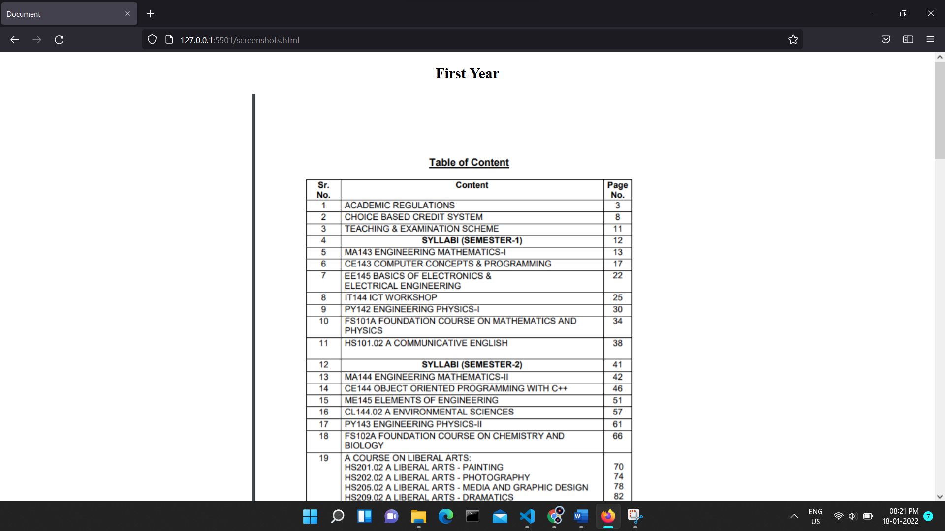

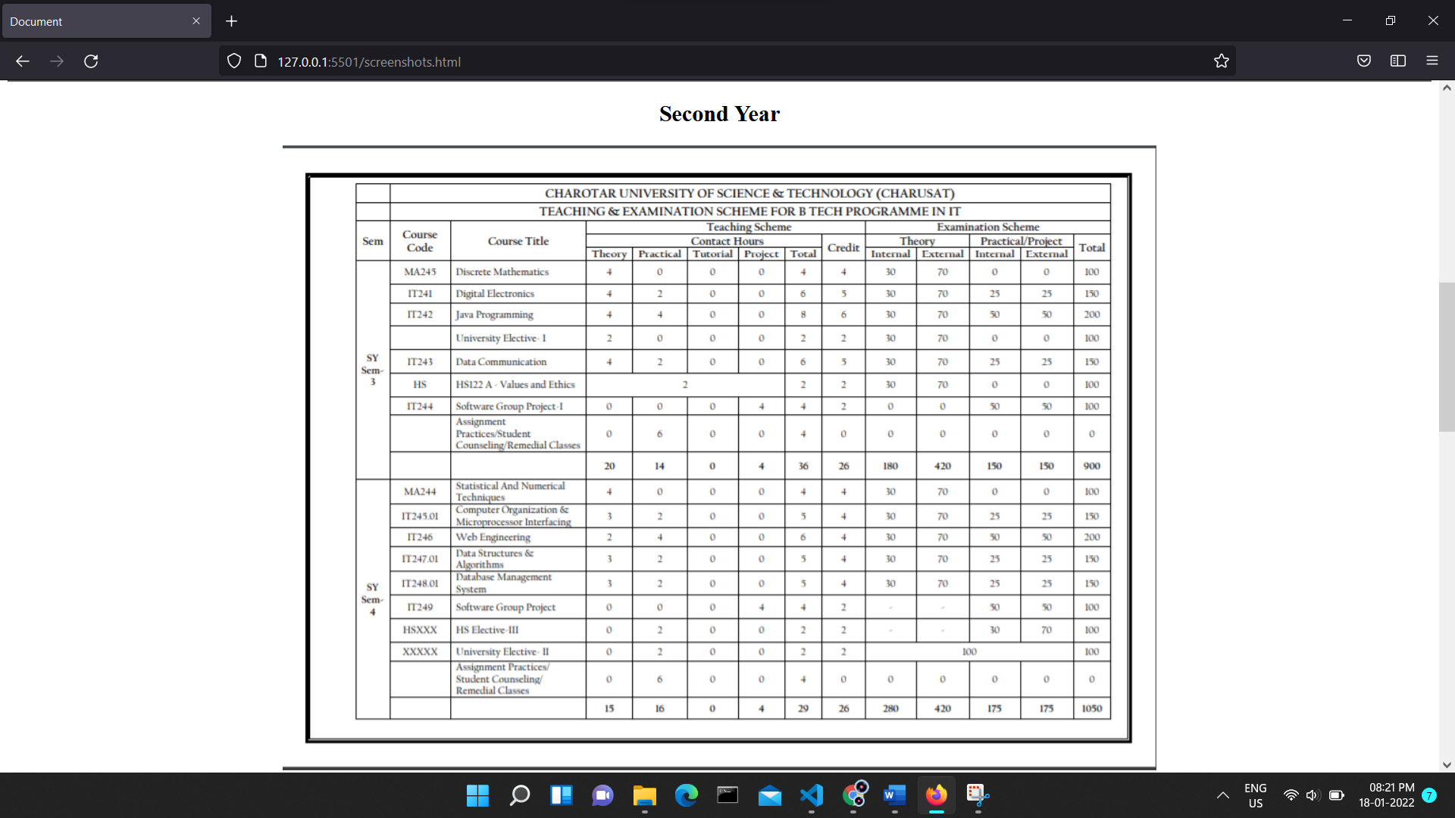

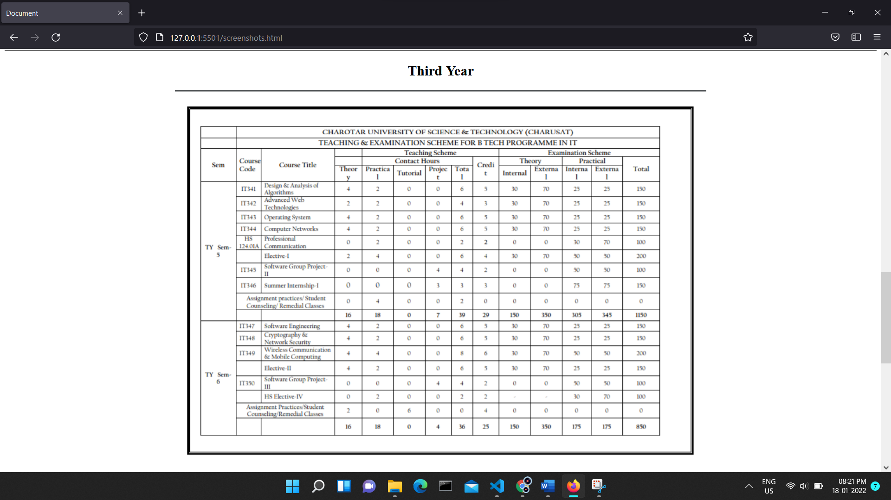

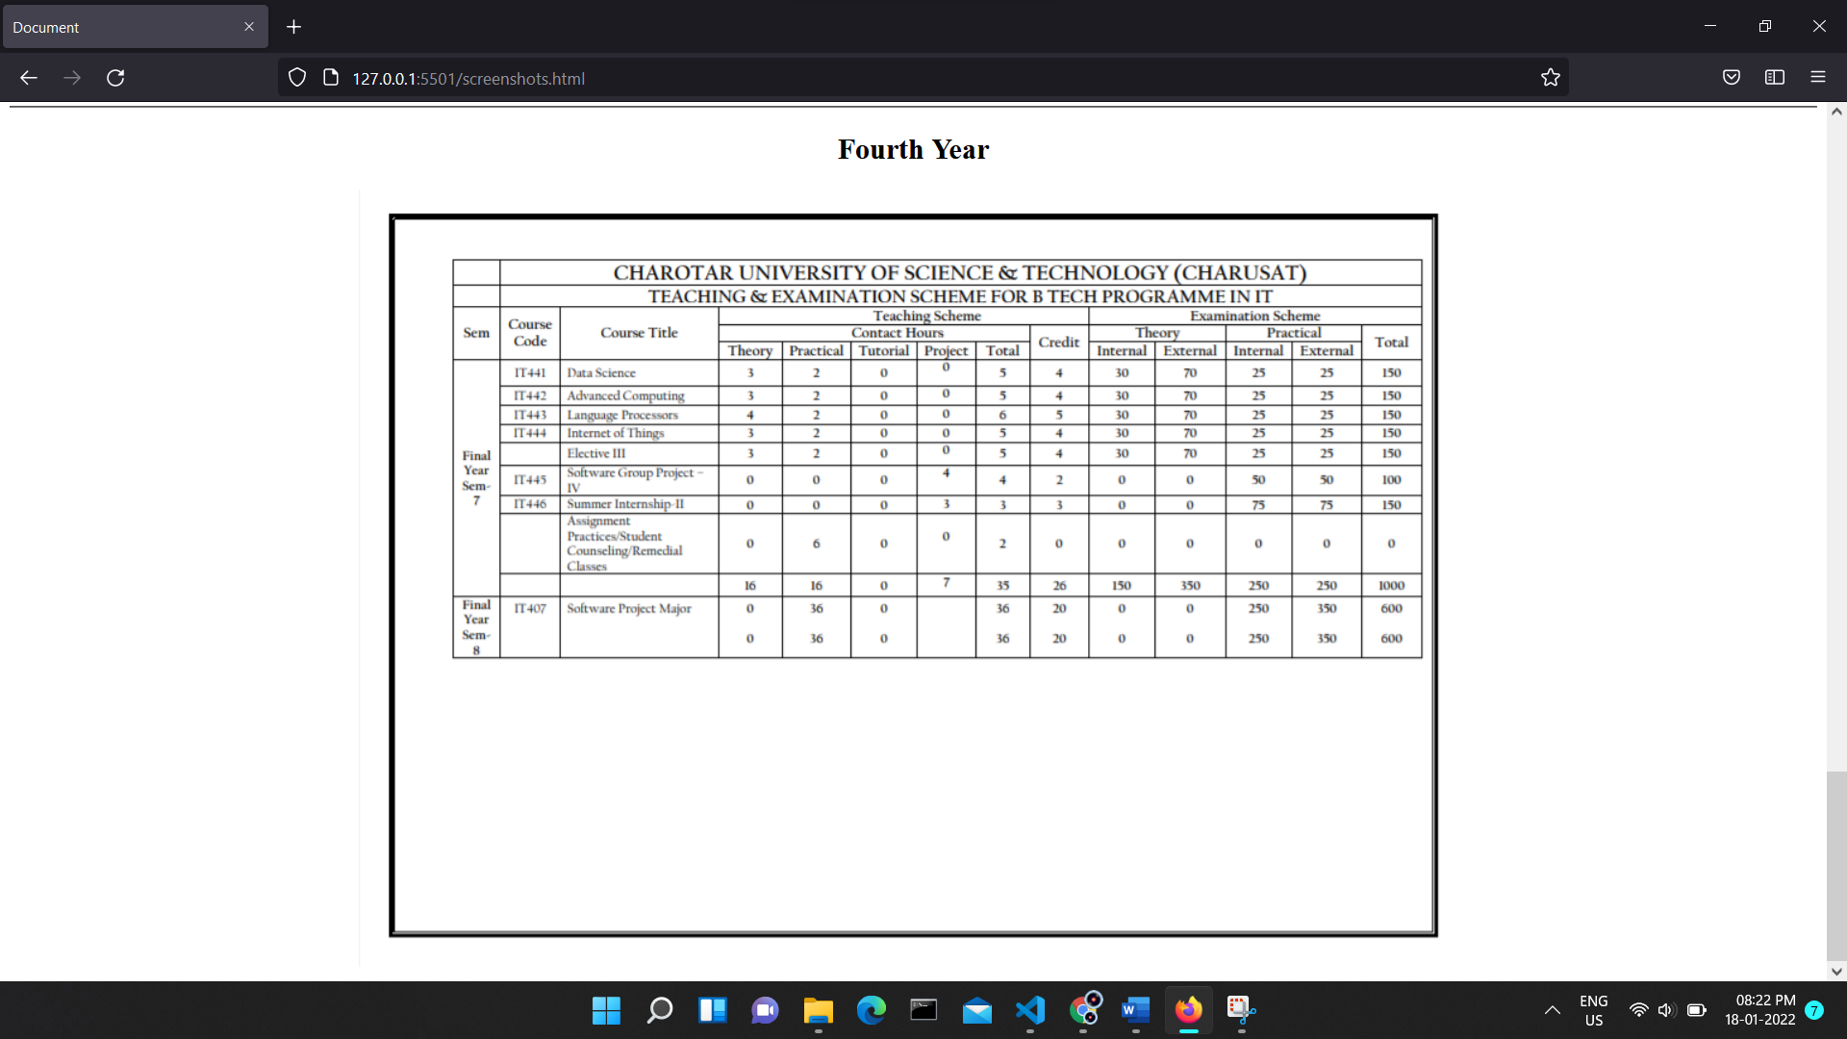

**Note: also it is given in the question that to display faculties details but am not able to find the data regarding it on any sources so not included in this practical file :)**